DEXTER AND WINTER’S DETECTIVE AGENCY
by Nathan Bryon
Teacher Resource Pack

Contents

INTRODUCTION 3
STORY 3
THEATRE ‘IN-THE-ROUND’ 5
CLASSROOM ACTIVITIES 7
TEACHER RESOURCES 10

INTRODUCTION

DEXTER AND WINTER’S DETECTIVE AGENCY is a new play by playwright Nathan Bryon, produced by Paines Plough and Theatr Clwyd. The play follows the characters of Dexter and his best friend Winter, 10-years olds who launch their own investigation when Dexter’s mum is arrested for getting mixed up in a jewellery heist. On their journey to uncover the truth and free Dexter’s mum, their detective work leads them to some surprising discoveries.
The classroom activities we’ve designed to support and build on your students’ experience of the play are there to help you, as their teacher, pull out and explore the themes in a fun and imaginative class room setting. These activities have all been made with the National Curriculum in mind:
‘All pupils should be enabled to participate in and gain knowledge, skills and understanding associated with the artistic practice of drama. Pupil should be able to adopt, create and sustain a range of roles, responding appropriately to others in role. They should have opportunities to improvise, devise and script drama for one another and a range of audience, as well as to rehearse, refine, share and respond thoughtfully to drama and theatre performances.’ National Curriculum
Through drama games and creative exercises based around DEXTER AND WINTER’S DETECTIVE AGENCY, this resource pack aims to deepen students’ social awareness and understanding. With activities that enable students to empathise with the different characters within the play, their situations and emotions, this resource pack seeks to explore and deepen students’ relationship with theatre in a creative and educative approach.

STORY

10 year-old Dexter wakes up one morning and can smell bacon. He runs downstairs and finds his best friend Winter tucking into a bacon sandwich, ketchup all over her face. Dexter’s mum, the coolest mum on the planet, reveals that she will be taking them to Thorpe Park for the day. It’s shaping up to be the best day ever.
The three of them have a wonderful day, with Dexter’s mum using all the tricks up her sleeve to get Dexter and Winter on the big kid’s rides. After winning a toy Zebra at a toy stand, Dexter’s mum disappears. Dexter goes to look for her and finds that she’s been arrested and is being detained by multiple police officers.
Dexter is taken to stay at Winter’s house. Winter’s vegan, hypo-allergenic mum is a lot less cool than Dexter’s. She insists on early bed-times and tries too hard to be ‘down with the kids’. She tells Dexter that his mum has been arrested for her involvement in a jewellery robbery.
At a classmate’s birthday party at a trampoline park the next day, all the kids tease Dexter about his mum being arrested, ask him if he knows where the diamonds are, and say lots of mean things about his mum and the fact that she is ‘poor’ and ‘works in a dump’. Dexter gets angry and ends up in a fight with another kid. Winter’s mum arrives to take them both home. She tells Dexter that he should write a letter of apology to the kid that he punched, and he agrees to do so. It’s apparent that Dexter is good at understanding when he’s in the wrong.
Dexter and Winter go to visit Dexter’s Granny Annie at the care home, where she is leading a vigorous exercise class. She tells them that Dexter’s mum had always been a ‘firecracker’ and that she had been to Youth Detention when she was younger, but that since having Dexter she has ‘totally turned her life around’. At this point Granny Annie forgets who Dexter and Winter are, and is taken off by a nurse. They are approached by Alfred, an ex-spy also staying at the Care Home. He tells them to start looking for clues.
Over the next 48 hours. Dexter and Winter set up ‘Dexter and Winter’s Detective Agency’, and launch their own investigation – a mission to free mum that leads them to speaking to lots of different people and to finding themselves in a number of surprising situations. At one point they stop by Dexter’s house on the way home so that Dexter can pick up his X-Box, and Winter finds a wad of post – letters from bailiffs. She doesn’t tell Dexter.
Eventually their efforts lead them to pinning down a new, credible suspect, and they report him to the police. Dexter goes to visit his mum in prison, bursting with excitement to let her know that he and Dexter have solved the crime, identified the thief and proved her innocence. It is only at this point that Dexter’s mum admits to Dexter that she did steal the diamonds. She is in a huge amount of debt, and the jewellery heist seemed too good an opportunity to miss at the time, although she deeply regrets it now. Dexter is angry, and doesn’t want anything to do with her. He goes home to Winter and her mum.
The final scene is set years later, when Dexter is 16. Dexter’s mum is coming out of prison and Dexter and Winter go to meet her with Winter’s mum in the car. They tell her that they’re taking her to Thorpe Park for the day.

THEATRE ‘IN-THE-ROUND’
We thought we’d tell you a little bit about in-the-round theatre. In this section you’ll find information on the history of in-the-round theatre and how we approach in-the-round theatre in 2017!
History:
Normally when we see a play the audience are all sat in rows facing the stage. This is called end-on theatre. Most traditional theatres are built like this. When the audience are sat all around the stage this is called in-the-round. Theatre in-the-round is actually the first way that plays were performed, going all the way back to Ancient Greece. In Ancient Greece most cities had a large, circular, open-air theatres built on hillsides. Some of them could seat more than 15,000 people! That’s as many as a small football ground. A great historical example of an in-the-round space is the coliseum in Rome! Can you think of any more?
However, after the Greeks and the Romans, theatre in-the-round became less popular and never caught on in Britain. Until the 1950’s when young British theatre-maker decided it was time for Britain to embrace theatre in-the-round. He was called Stephen Joseph. He thought that performing theatre in the round would make it more exciting and convince people that the theatre was even more exciting than staying at home watching TV.
People loved going to see his plays and more in-the-round theatres began to spring up around the UK. There are in-the-round theatres at the Royal Exchange in Manchester, the Orange Tree in London and The Dukes Theatre in Lancaster. Not to mention the original Stephen Joseph Theatre in Scarborough.

Why do we love in-the-round so much?
Why in-the-round? Well, it's one of the most exhilarating ways to watch a play – a true 3D experience. As playwright and Paines Plough trustee Simon Stephens says, "there's no theatrical architecture that challenges or interrogates what it is to be a human being more than theatre in-the-round". With only five permanent in-the-round venues in the UK, few audience members will have sat encircling a play. We hope Roundabout will create a sense of event, and attract audiences like Imax cinemas attract filmgoers.
One of the main things we love about in-round-theatre is that there are no bad seats! This is especially true in Roundabout where you can see the stage clearly wherever you sit. You’re never more than 2 metres from the action.
Staging a play in-the-round can be tricky though. You have to consider that the audience are sat in front of you and behind you no matter which way you face! This makes it important that actors keep moving when acting in-the-round. If someone is in one place for

too long, the audience behind them will get frustrated that they can’t see their face. This also means that big pieces of set can be difficult to use because they can easily block the actors from the view of the audience.
We think these challenges are worth over-coming. There’s nothing more exciting than sitting close to the action at a brilliant play.
Is there an in-the-round theatre near you?

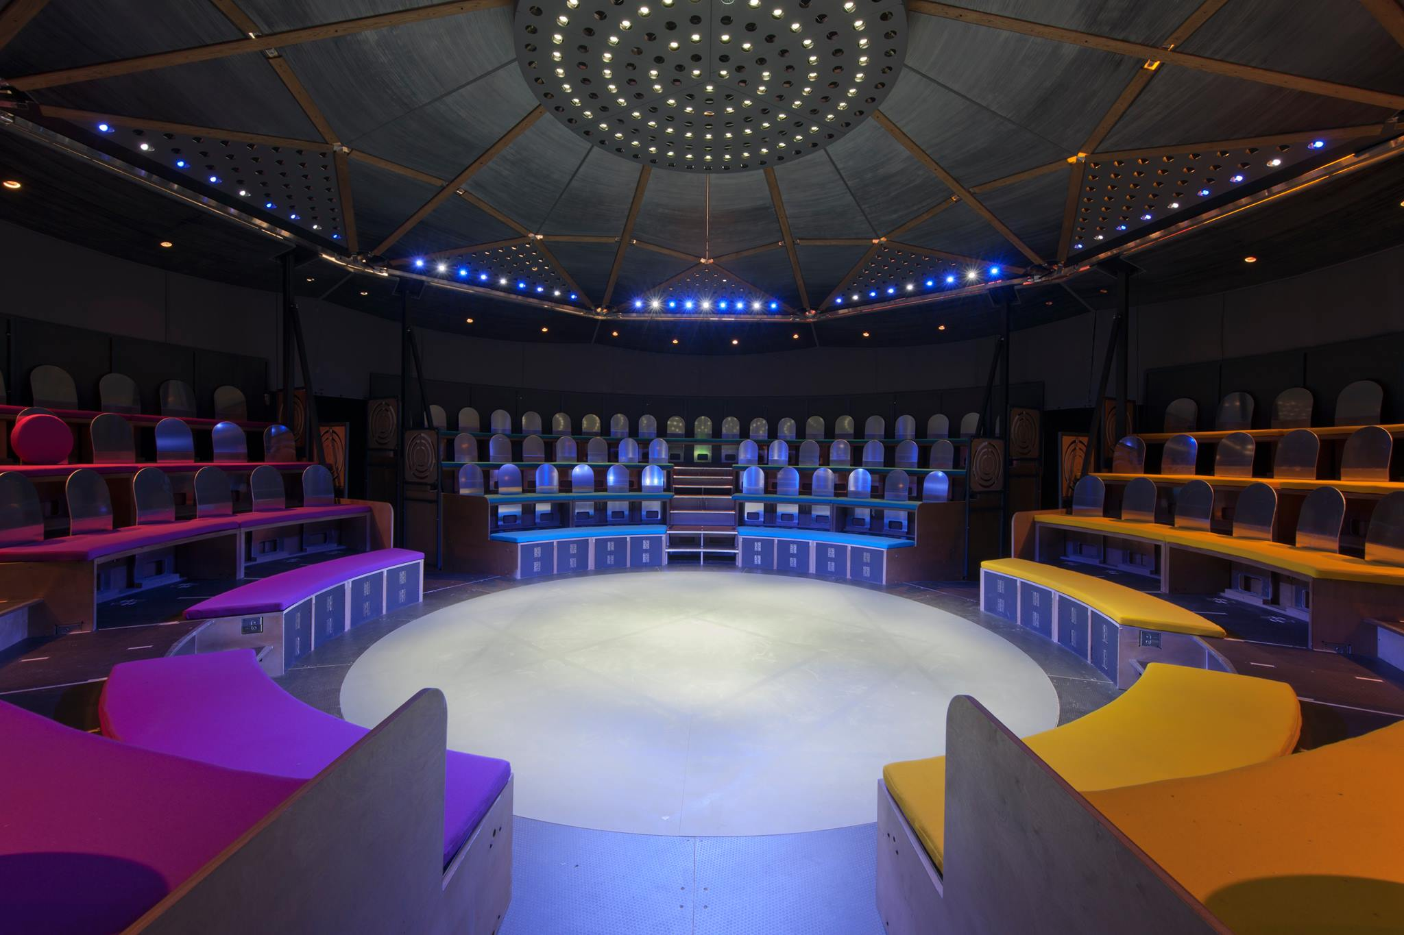
Inside ROUNDABOUT

CLASSROOM ACTIVITIES

This series of activities looks at Dexter and Winter’s story, and how certain events within the story may affect the characters.
Stage 1
Strategies: Traffic Lights , still image, children-in-role, scene work in groups, improvisation, thought tracking.
- Warm up. Play a game of TRAFFIC LIGHTS. Traffic Lights is another version of musical statues. Ask the children to walk around the room – aware of the space and each other, making sure they don’t bump into one another. Instruct them that the rules of the game are the following: When you shout GREEN that means go (if they’re already moving, they carry on doing so). When you shout AMBER that means one of two things 1. Slow down if you’re already moving 2. If you’re not moving, get ready to move. Finally RED, means stop (if they’re not moving then they continue to stay still). Students are knocked out of the game by following the wrong command or doing the wrong thing – sometimes add in different colours to catch them out.
Opening discussion
‘What happens when a grown-up is in trouble?’ Ask your students this, writing up all their responses on paper and pin them around the room. These written responses will serve as a visual reminders of the overall theme of the production over the follow lessons.
Story Whoosh
Using the Story Whoosh in your resource pack, ask your students to sit in a circle. Read through the Story Whoosh, allowing time for the students to come up in groups and make an ensemble still image. As you read each line, pick 1-3 students quickly at random to form a still image. Multiple images can be made for each section of the Story Whoosh, moving through different students.
Group scenes
Looking at the scenes you will have just gone through, put them into groups of 3 and ask them to think about the characters in those scenes and how they might have been feeling. Ask them to pick one of the scenes and to recreate a short performance of it. Give each group 10 minutes to work on a person, and then ask each of them to perform theirs to the rest of the class.

Stage 2 Scene work / Creating Characters
Warm up
HYPNOSIS – Ask your students to get into pairs. Partner A holds their hand out in front of Partner B. Partner A then moves their hand around slowly, and it is the aim of Partner B to keep their face in from of their hand for a long as possible whilst it’s moved.
Opening Discussion
In the lesson we’re going to look at actions and their implications on feelings. For the opening discussion, focus on a specific part of Dexter and Winter’s story:
Winter’s mum tells Dexter that his mum has been arrested because she was involved in a jewellery robbery.
Ask some of the following questions to the students.
- How might Dexter be feeling? - What questions might Dexter be thinking?
- How would you feel in Dexter’s situation?

At the party
With all of what you’ve discussed in mind, ask the children to create 2 short scenes (splitting them into groups of 4). Each scene should imagine what Dexter’s arrival at his friend’s party would have been like. One scene should explore how Winter feels about the situation, whilst the second scene should explore how the other kids would be feeling and why they decided to start picking on Dexter. After each group performs their scene, ask the rest of the class their thoughts on the scene, and ask them what they’d do in the same situation.
Stage 3 Creative writing / Improvisation / Hot Seating / Physical performance
Warm Up
ZIP ZAP BOING. Ask all the students to stand in a circle. ZIP ZAP BOING is a quick fire, concentration game which requires students to be fast on their toes and focussed. Each student holds their hands in front like a lazer – the aim is the game is a shoot out. Zips can only be shot to players on their immediate left and right. Zaps can only be shot across the circle. Boings are bounce backs i.e. if someone zaps and the person zapped says ‘BOING’ the zap transfers back to the zapper and they must shoot again. You are knocked out of the game if you hesitate. Last pair standing must stand with their backs to each other, the teacher picks a category i.e. Biscuits. Any time the teacher says a type of biscuit they step forward one pace – when the teacher says something that isn’t a biscuit i.e. tiger – the first to turn and zap wins the game.

Opening Discussion
Admitting that we’ve done something wrong
In this lesson we’re going to look at relationships, and the efforts our loved ones go to in order to take care of us, and similarly what we do for them in return.
This is not a hairbrush
‘This is not a hairbrush’ is an improvising game – which for the purpose of this lesson we will theme around ‘Looking after each other’. The rules of the game are simple; one person stands in a circle and mimes brushing their teeth with a toothbrush. Using their image, another person comes into the circle, saying FREEZE and turns the original image into something else i.e. brushing your hair becomes pushing a boulder up a hill, etc. Let the students do whatever comes to mind, for the first five minutes and then focus the second half around the activities discussed in the opening discussion.
Hot Seating
If it’s useful for this exercise, use the Story Overview resource to recap over the events that happened in the play before going into Hot Seating. First though, ask the students to see if they can recap the play themselves as a group, using the resource to fill in any missing plot that they may have forgotten.
Hot Seating is a way of developing characters stories beyond that which we see in the play, asking students to imagine the lives of the characters past the pages of the script. For hot seating we’re going to ask the students to become Dexter’s mum, Winter or Winter’s mum. Before students assume the role and are asked questions, give each student some paper and a pen and ask them to put down everything they know about that character – these are all the things that we’ve learn from watching the play, e.g.
Dexter and his mum live on their own. Dexter’s mum spends a lot of money on Dexter.
Once they’ve done this, ask them to build the character more, thinking about how they behave in the play e.g. Winter’s favourite snack is a bacon sandwich. Ask them to be as in depth as possible, considering how all of this information makes them behave and therefore how they would then perform that character physically. Once they’ve done this for a further 5-10 minutes, put a seat at the front of the room and ask the students to sit in it one at a time assuming the role of the character that they’ve been developing and have the other student ask them questions e.g. Dexter’s Mum: Why did you want to take Dexter and Winter to Thorpe Park? Winter: Why is Dexter your best friend? Winter’s mum: Did you enjoy looking after Dexter?

TEACHER RESOURCES

Story Whoosh
The robbers, dressed as unicorns, are making their escape from the jeweler’s store. Dexter’s mum, dressed as a Zebra, comes and picks them up on her motorbike.

Dexter wakes up one morning and can smell bacon. He runs downstairs and finds Winter tucking into a bacon sandwich with his mum in the kitchen.

Dexter’s mum causes a distraction so that Dexter and Winter can get on The Exterminator ride at Thorpe Park.

Dexter’s mum gives Dexter a toy Zebra that she’s won in a game.

The police arrest Dexter’s mum.

Dexter and Winter listen to the news on the radio about the Grove Jewel robbery.

The kids at the birthday party tease Dexter about his mum being arrested, and he gets into a fight with one of them. Winter’s mum arrives to take them home.

Dexter and Winter take part in Granny Annie’s vigorous exercise class and try to ask her what she thinks they should do.

The ex-spy in the care-home tells Dexter and Winter how to start looking for evidence. They set up Dexter and Winter’s Detective Agency.

Winter films Dexter interviewing the charity-bucket man about what he saw on the night of the robbery.

Dexter and Winter act as backing dancers for Sharon the busker.

Dexter and Winter stop by Dexter’s house on the way home to pick up the X-box. Winter finds post labelled ‘URGENT’ and ‘FINAL WARNING’. She stuffs the letters in her pockets.

Dexter and Winter follow the man in the Zebra outfit to the jewelry store and watch him looking at the rings in the window.

Dexter and Winter hide from the ticket inspector in the toilets on the train.

Dexter and Winter watch Zebra man propose to his boyfriend in the airport. Everyone around them celebrates when he says yes. Winter takes lots of photos on her phone. Dexter and Winter are excited about how much evidence they have.

Winter’s mum comes to pick Dexter and Winter up from the police station. She is really cross. Winter realizes that she lost her phone when they were running away from the police. Dexter is really angry with her and she tells him about the bills that she found in his house, and that maybe his mum DID steal the diamonds. They don’t talk all the way home.

Winter’s mum finds Dexter and Winter’s crime lab and is really impressed. She asks them about zebra man and they tell her the full story. She calls the police.

Dexter goes to visit his mum in prison. He tells her that he and Winter have found the jewellery thief and that she’ll be out of prison in no time. His mum seems sad and he doesn’t understand why.

Winter watches the police come and arrest Zebra man from the butchers (where he works).

Dexter’s mum tells Dexter that she did steal the diamonds, and that she is guilty. He is confused and angry. She tries to give him a hug but he won’t let her.

Years later, Dexter and Winter collect Dexter’s mum from prison and take her to Thorpe Park.

