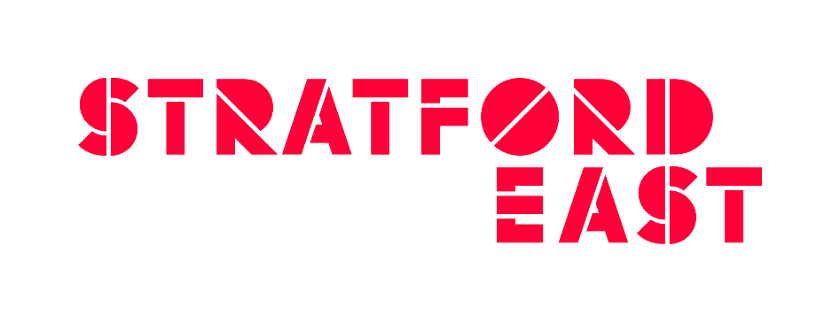
APPLICATION FORM
BBC NORMAN BEATON FELLOWSHIP AUDITIONS – 11th January 2019

To apply for a place at the Norman Beaton Fellowship audition at Theatre Royal Stratford East on Friday 11th January 2019 please complete and return this form – together with your acting CV - by 26th November 2018. (Successful applicants will be notified of their audition place by 14th December 2018

Full Name _________________________________________________________________
Address __________________________________________________________________
_________________________________________________________________________
Postcode _________________________________________________________________
Mobile ___________________________________________________________________
Email ____________________________________________________________________
Eligibility
I confirm I am eligible to apply for a place at the 2019 Norman Beaton Fellowship audition at Theatre Royal Stratford East.

PLEASE TICK AS APPROPRIATE:
- I have not attended an accredited drama school course.
- I am over 18 years old on or before the Saturday 22 July 2018.
- I can provide information on my recent professional acting work and the names of two referees.
- I can prepare two contrasting monologues (lasting no more than three minutes in total, no need to memorise) for the audition.
- I am available on all the following dates:
Friday 11th Jan 2018 Workshop/Audition day (Theatre Royal Stratford East)
19th February 2019 Semi-finals (London)
18 – 19th March 2018 Finals (London)
- If I am one of the two successful applicants, I am eligible to work in the United Kingdom for the duration of the contract (20 July - 20 December 2019).

MONITORING FORM

How do you identify you gender?
Male
Female
Non Binary
Other (please specify)______________________________
Prefer not to say

What age group do you belong to?
0-19
20-34
35-49
50-64
65+

How would you define your sexual orientation?
Bisexual
Gay man
Gay woman/lesbian
Heterosexual/Straight
Prefer not to say

How would you describe your ethnic origin?
English/Welsh/Scottish/Northern Irish/British
Irish
Gypsy or Irish Traveller
Any other white background
White and black Caribbean
White and black African
White and Asian
Any other mixed/multiple ethnic background
Indian
Pakistani
Bangladeshi
Chinese
Any other Asian background
African
Caribbean
Any other Black/African background
Arab
Any other ethnic group
Prefer not to say

Do you consider yourself to have a disability?
Non disabled
Visual impairment
Hearing impairment/deaf
Physical disabilities
Cognitive or learning disabilities
Mental Health condition
Prefer not to say
Other long term/chronic condition

Please send completed form (and acting CV) by 26 Nov 2018 to: dhale@stratfordeast.com
or by post to: Daisy Hale, Assistant Producer, Theatre Royal Stratford East, Gerry Raffles Square, London E15 1BN

Good luck!

